**Network Layer Services**

**1. Packetizing**

Packetizing encapsulates the payload in a network-layer packet at the source and decapsulates the ‘payload’ from the ‘packet’ at the destination.

Every layer in Networking has its concerns or design issues.

One of the central issues of the network layer is packetizing.

To understand the concept of packetizing, we will consider the image below.

The layers in the above image are the layers in the TCP/IP architecture.

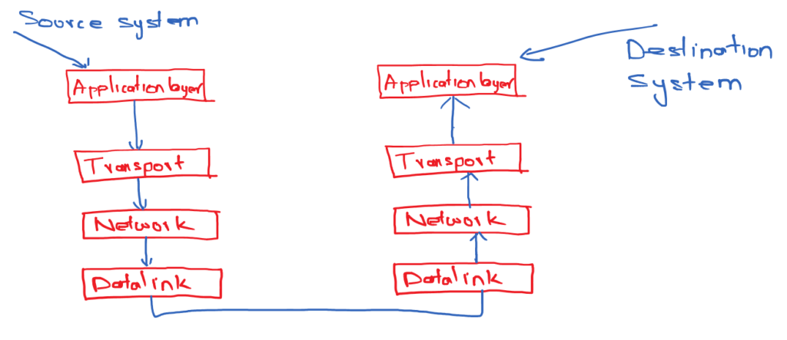

The message or the data generated at the application layer is transferred to the transport layer.

As shown in the above image, the transport layer header gets added to that message, which is called a payload.

Now the payload of the transport layer is transferred to the network layer.

At the network layer, the network layer header gets added to that message.

This process of adding or encapsulating the network layer header to the source’s payload is called packetizing.

The packet is transferred to the data link layer to which the header will be added, called framing.

Similarly, the decapsulation of the header gets done at the destination.

**2. Routing and Forwarding**

Network routing is the process of selecting a path across one or more networks.

Forwarding is the action applied by each router when a packet arrives at one of its interfaces.

To understand this better, consider the image shown below.

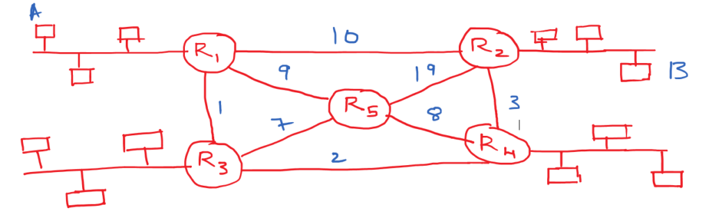Network Layer Services Routing and Forwarding

In the above image, all the networks are connected to the routers.

If Computer A wants to communicate with Computer B, it has to take a path so that the communication should be fast.

The router will run some routing algorithms to find the distance between all the possible paths to have faster communication.

The outcome of those routing algorithms will generate the forwarding table or routing table.

The forwarding table will decide which interface must be selected for the data to be transmitted to the destination.

In the above diagram, the shortest path is 6.

To transmit the data to B, it has to take Interface I1. This information is stored in the forwarding table.

**Packet Switching Datagram Approach**

The packets received at the router will get switched to the other router, and the ‘packets are switched’ in two different ways.

1. Datagram switching [Connectionless Service]
2. Circuit Switching [Connection Oriented Service]

In this class, we will discuss datagram switching.

In the next class, we will discuss Circuit Switching.

To understand datagram switching consider the image below.

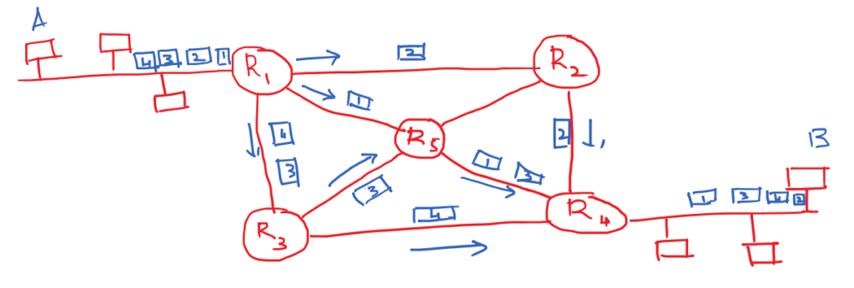Packet Switching Datagram Approach

Packets 1, 2, 3, and 4 are transmitted by system A in the above image.

The packets are not destined to a particular interface in the datagram switching.

In datagram switching, packets get randomly transmitted through any interface.

The problem with the datagram switching is at the destination, and the packets get received in random order.

The destination has to rearrange them in order.

### Packet Switching Virtual Circuit Approach

The virtual-circuit approach will create a circuit before transmitting the data, unlike the datagram approach.

It is also called as connection oriented service.

The entire switching of the virtual-circuit approach happens in three different phases.

1. Setup phase
2. Data transfer phase
3. Tear down phase

#### Setup Phase:

A virtual circuit will get established between the source and destination in the setup phase.

The source system will transmit a request packet to the destination to establish the circuit.

In response, the destination system will transmit an ‘acknowledge packet’ to the source system.

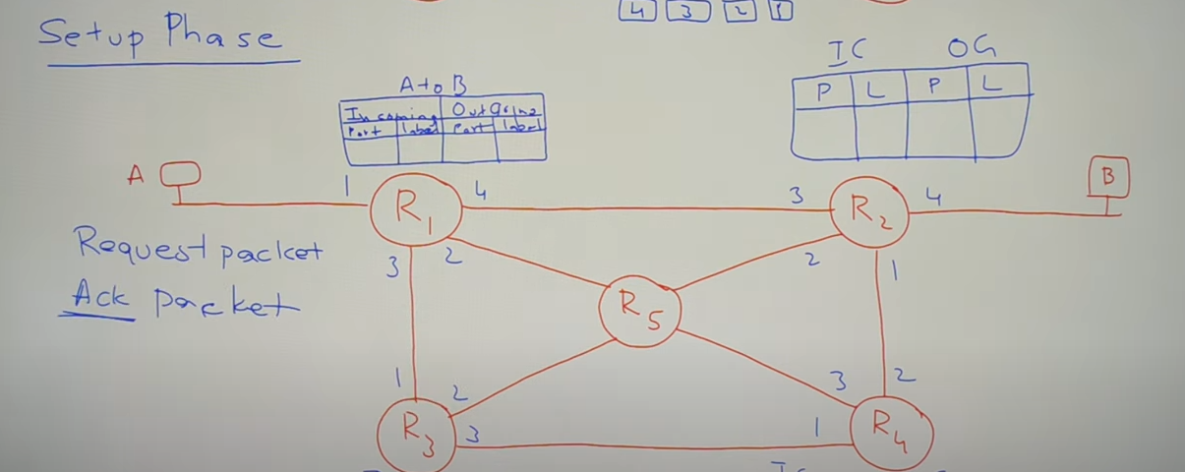

#### Data transfer phase:

After establishing the connection between the source and destination, the source system will transfer the data to the destination.

#### Tear down phase:

After transferring all the packets in the data transfer phase, the source will send a special packet to tear down the established connection.

